Weekly Report Out 2

Team: Drone Link

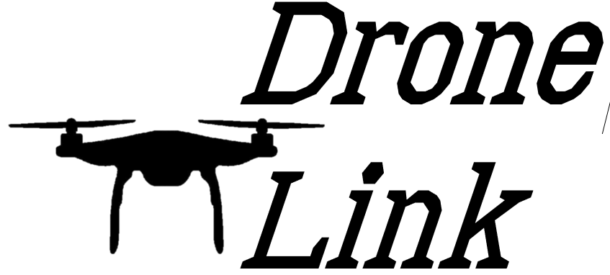Sam Forest, Alex Holt, Vincent Krenz, Lucas Larocco, Blake Masbruch

9/25/2020

Senior Design Adviser: Professor Wiedenhoeft

ScrumMaster: Vincent Krenz

Current Cadence: 1

**Progress**

We split up on what we want to focus on for future cadences to ensure the systems we are researching will work best for each person as well as the entire project. This means I, Vincent, split off with Alex to focus on testing, Lucas focused on databases, Blake on front end, and Sam on Back end. This splitting up of project portions will be a good way to let everyone be invested in their work environment however, to make sure all our parts work together we have documented our findings in wikis on Gitlab. I also plan on checking in on compatibility throughout the process as ScrumMaster.

Sam Forest – Worked on Spike Timer, Clarifying of API from PO, Researched Back End frameworks (Express), wrote Wiki on framework decision

Alex Holt – Further breakdown of projects and tickets, worked on backlog, Research of Testing frameworks for project portions

Vincent Krenz – Testing framework research, working on Selenium POC, Testing document/Wiki in process, Integration checking

Lucas Larocco – Database research, Setup sample DB server, database response time with real time data, testing Mongo next

Blake Masbruch – Front end research (React), collaborated with Vincent to choose React for front end, Building out react skeleton

**Future Progress**

Our future progress will be the completion of research and the continued framing of the project along with cadence two setup. We still have the tickets, Research alternatives to mqtt, wireframe web app, and research timer hardware to complete this second week of cadence one.

**Reflection**

Overall our pace has been pretty good for the first week of work, we have had some trouble with Gitlab’s time logging as it hasn’t let us log time with varied errors, that means some of our times may not be posted at the correct days/times. We also decided on RetroRabbit because of its slack integration for our retrospectives and are working on getting a definition of done completed by the end of the cadence.